=====================================================

|| Functional and Performance Test For Marvin EBAY ||

|| P/N TLM132XX501 S/N:001 ||

|| Date:08/03/2018 Time: 13:36 Test-Conductor: Elie Talias ||

|| Tester P/N yyyy-yyyyyy-yyyy S/N:10 ||

|| POWER SUPPLY P/N xxxxx ||

|| ||

|| ||

=====================================================

EBAY CONTROLLER TEST DATA SHEET

P/N: 414-8005 Date:6/12/2007 Time: 15-00

S/N: @@@@@ Tested by: ##########

Hardware Rev: BLDC_60A_V6 Approved by: ##########

Software Rev: 5.3.9

Equipments Used

Equipments Model No Serial No

Power Supply

Digital Multimeter

CAN Interface

Resistance Decade Box

PC

AHU-L (47) P/N 413-8005-1

AHU-R (63) P/N 413-8005-2

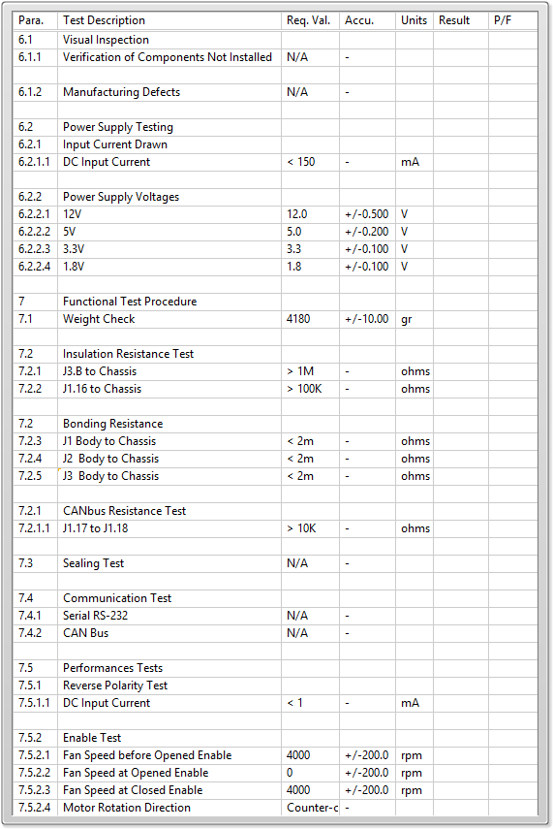

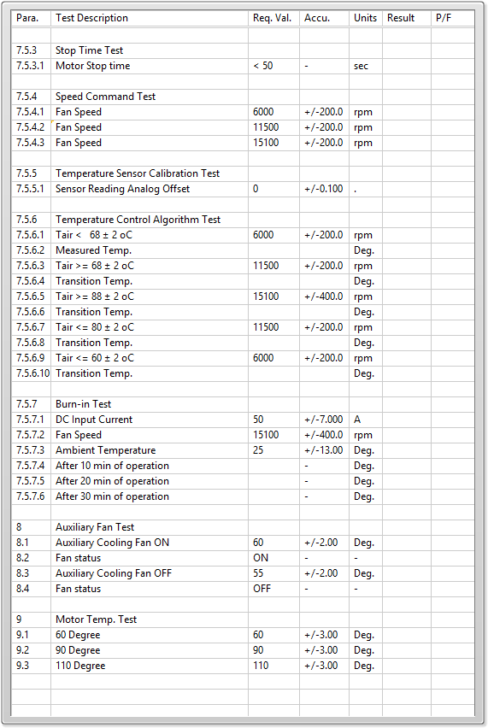

General result:

Test-Operator:____ Elie Talias_________ Q.A.:__________________________